**Unwrapping the Layers of Cloud Architecture: A Journey from Raw Data to Useful Insights**

The Cloud Architecture is a trip from Unprocessed Data to useful insights for better understanding.   
Within the dynamic field of data management and analytics, cloud architecture is consisdered as the cornerstone that facilitates the health of digital ecosystems. Envision a symphony of interdependent parts, each with a specific function in coordination of the Data flow. This article by me can help the reader on a guided tour through the layers of cloud architecture, explaining its difficulties that might come in the way and how it affects how we use data.

**Table of Contents**

* Introduction
* Navigating the Cloud
* Company Vision
* Challenge
* Mission
* Pipeline Strategy
* Company’s Cloud Architecture
* Benefits
* Summary

**Introduction**

As part of my semester capstone project, I am using the hypothetical scenario of Dollarama, a leading retail giant, embarking on its journey towards harnessing the power of cloud architecture for effective data management. This article aims to go deep into how Microsoft Azure, a prominent cloud computing platform, assists Dollarama in using the data for Data decision-making and business growth.

**Navigating the Cloud: Data Flows with Microsoft Azure and Dollarama**

In an times dominated by information technology retail giants like Dollarama are using cloud computing to carryout the operations and enhance decision-making through data-driven strategies.

This article presents an imaginary situation where Dollarama with the help of Microsoft Azure to overhaul its data management practices. By adopting Azure's cloud architecture, Dollarama aims to achieve scalability, flexibility, and operational efficiency, essential for managing vast amounts of retail data effectively.

**Company Vision**

Dollarama’s focus is to create a cloud infrastructure that seamlessly adapts to Dollarama’s growing inventory demands, ensuring efficient stock management and minimizing overstock. This is done literally in order to maintain

**Scalability**: The capacity to quickly scale in response to demand. This guarantees that throughout the year, Dollarama's infrastructure can adapt to changes in inventory levels.   
**Efficiency**: Having real-time data and insights into inventory levels across all stores allows for optimal stock management. This reduces the likelihood of waste and overstocking.  
**Cost-Effectiveness**: Pay-as-you-go cloud infrastructure can be less expensive than keeping on-premise servers, particularly for expanding businesses.

**Challenge in the way**

The challenge for Dollarama is to close the gap between their present data cloud architecture and their ideal situation, which includes automated reordering, effective inventory management, and well-informed decision-making.

**Mission**

Our mission is to design and implement a robust data cloud architecture that empowers Dollarama’s inventory management. By leveraging real-time data, predictive analytics, and seamless scalability.

Dollarama is trying to building a powerful cloud system to manage inventory like a pro.

Which helps in

* Make sure their Data is secure.
* Expand in size as Dollarama expands
* Always show them their precise stock amount
* Forecast the next big thing to sell

**Pipeline**

The pipeline is known as the process of ingesting unprocessed data from multiple data sources, then doing its transformation, and then storing it for the purpose of analysis and others in a data lake or delta lake.

1. Data Ingestion: When data is ingested into Azure Data Lake Storage, Azure Data Factory helps in doing it from multiple Data sources.  
  
2. Data Storage: for the purpose of scalable ingested data storage, services of Azure Blob Storage or Azure Data Lake Storage are consumed.  
  
3. Data Processing: Data processing work like pipeline transformation, and cleansing are handled by Azure Data Factory.  
  
4. Analysis and Insights: For the purpose of data analysis and actionable insight extractions a, tools such as Azure Synapse Analytics can be handy.  
  
5. Visualisation and Reporting: Power BI creates useful dashboards and reports for the purpose of visualisation by integrating with Azure services in an efficient manner.

**Dollarama’s Cloud architecture**

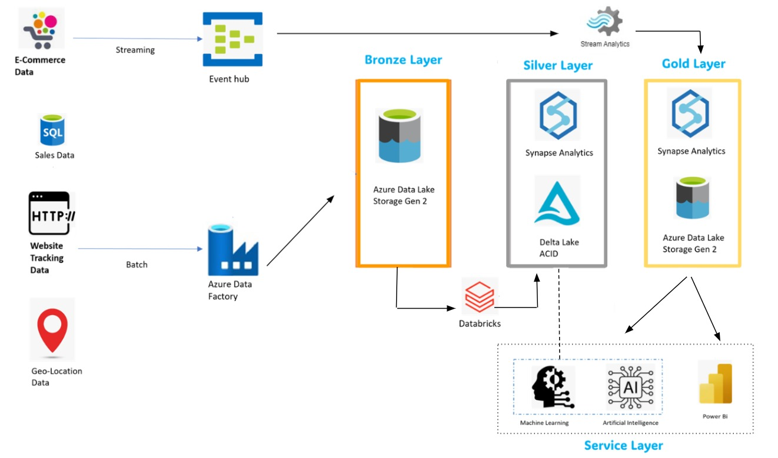

**1. Data Ingestion: Gathering Begins**

Dollarama has plenty of Data sources from where it collects its data, Here are the examples:

* **E-Commerce Data**: Dollarama’s online store records transactions—cheap toys, party supplies, and quirky gadgets. Think of it as the digital cash register ringing up sales.
* **Sales Data**: Their point-of-sale systems hum with activity, tracking every penny spent. These are the loyal foot soldiers tallying up the receipts.
* **Website Tracking Data**: Dollarama’s website observes user clicks, revealing which items intrigue shoppers. It’s like watching customers browse the aisles.
* **Geo-location Data**: Where are customers? Mapping their locations helps optimize store placement. Imagine plotting little flags on a map.

**Event Hub**  is a big data streaming platform. As a platform as a service (PaaS), this event ingestion service is fully managed which stands at the entrance, welcoming real-time data like eager shoppers. Meanwhile, **Batch Processing** handles bulk data through **Azure Data Factory**—

At the foundation of effective data management is robust data extraction, where Dollarama needs to capture information from diverse sources, Microsoft Azure facilitates this through Azure Data Factory.

**2. Bronze Layer: Storage for Raw Data**

Bronze layer is at lowest tier storing only the raw data, there is no transformation performed in this layer on data. The Data gets ingested into **Azure Data Lake Storage Gen2**. Dollarama dumps raw data here.

It’s like tossing random items into a bargain bin. Unstructured, untamed, but secure. Sales receipts, website logs, and geolocation breadcrumbs coexist. It’s the treasure chest waiting to be unlocked.

**3. Silver Layer: Contains cleaned, filtered data**

Silver layer takes raw data from the Bronze Layer, polishes it, and enriches . All the cleansing, transformation is done in this layer to make data enrich . Curation layer plays important role in Data Refinement and prepare for the consumption of Machine Learning and Artificial Intelligence teams for bringing out some useful insights and for the consumption of Gold Layer.

**Synapse Analytics** which is an analytics service for data warehouses and big data systems. This service integrates with Power BI, Machine Learning, and other Azure services. joins the act. It plays . Insights emerge: “Popular items in Quebec!” or “Trending toys for toddlers!” It’s like finding hidden gems in a cluttered attic. **Delta Lake** ensures **ACID transactions** that stands for Atomicity, Consistency, Isolation and Durability.

**4. Gold Layer: Ready for Display**

Gold Layer: It is also an aggregation layer

More read-optimized and de-normalized data models with fewer joins are used in the Gold layer, which is used for reporting.

**Synapse Analytics** steps in here. It’s refines the data in this layer and makes it more optimize for specific business use cases:

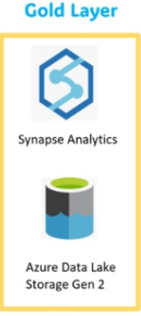

* + - Reporting: Crafting dazzling reports for executives.
    - Machine Learning: Fuelling predictive models.
    - Production Applications: Powering real-time systems.

**Data Flow from Gold Layer**: Insights flow downstream:

* + - To business dashboards (like Power BI) for visual storytelling.
    - To machine learning pipelines, where algorithms learn and predict.
    - To production systems, making real-world decisions.

In this symphony, the Gold Layer isn’t just data—it’s wisdom.

**5. Service Layer :** Service layer arranges the interaction between users and cloud services

In service layer tools like **Power BI** are the reporting powerhouse. Users create interactive visualizations, reports, and dashboards here

For example,

* “Top-selling categories this week!”
* “Profit margins on Toys!”
* “Customer footfall patterns!”

**Machine learning and Artificial intelligence** teams in access the Service Layer to train models, make predictions, and automate decision-making.

The Service Layer streamlines Dollarama’s operations, making their codebase cleaner and more maintainable.

**Summary**

With the help of Microsoft Azure cloud solutions retail giants like Dollarama can make significant strategic advantages. Because of Azure's scalable, and adaptable cloud infrastructure, Dollarama can better manage its massive data and transform that data into actionable insights that helps Dollarama to make data driven decisions and business growth.  
Azure provides businesses with the tools which assists them to use data effectively and maintain their relevance in a market that is changing quickly. Data is an asset in the digital age. The hypothetical journey of Dollarama took with Azure explains how supply chain logistics, customer engagement, and other retail operations can be strategically develop by the strategic application of cutting-edge cloud architecture.

**References**

<https://learn.microsoft.com/en-us/azure/architecture/solution-ideas/articles/azure-databricks-modern-analytics-architecture>.

Class Room Presentations

<https://www.databricks.com/glossary/medallion-architecture#:~:text=Gold%20layer%20(curated%20business%2Dlevel%20tables)&text=The%20Gold%20layer%20is%20for,quality%20rules%20are%20applied%20here>.